

END OF TERM 1 2024 EXAMS

GEOGRAPHY PAPER 2

SENIOR FIVE

Time:2hrs 15mins

**Instructions to candidates**

* This paper has two sections A and B
* Attempt 3 questions in all
* Attempt one question from section A and two questions from section B

**SECTION A**

1. Study the table below showing total amount of wheat exported by Canada between 2000 and 2006 and answer the questions that follow.

|  |  |
| --- | --- |
| Year | Wheat production in 0000 s tonnes |
| 2000 | 237 |
| 2001 | 432 |
| 2002 | 345 |
| 2003 | 530 |
| 2004 | 620 |
| 2005 | 750 |

1. Draw a simple bar graph to represent the information from the above table
2. What are the advantages and dis advantages of using the above statistical diagram.
3. Explain the roles of wheat growing to the development of Canada

**Section B**

1. (a) Examine the silent features of shifting cultivation in world.(10 mks)
2. Why is shifting cultivation persisting in the world.(15 mks)
3. Account for the development of Nomadic pastoralism in Africa.(25 mks)
4. Account for the development of plantation farming in either south Africa or Liberia(25 mks)
5. Asses the role of plantation farming to the development of either Ghana or Malaysia.(25 mks)

***“There is nothing that succeeds like success***.”

**END OF TERM 1 2024 EXAMS**

**GEOGRAPHY PQPER 2**

**SENIOR FIVE**

**TIME 2HRS 15MINS**

**Instructions to candidates**

* This paper has two sections A and B
* Attempt one question from section A and two questions from section B

**SECTION A**

1. For any field work you have carried out as a group or an individual,
2. State the;
3. Topic of the study(2 mks)
4. Objectives of the study(3mks)
5. Explain the activities you carried out before going for your field work study (7mks)
6. Explain any three methods you used to correct data during the field work study (9 mks)
7. Explain the problems you faced during the field work study.(4mks)

**SECTION B**

1. (a) Describe the relief regions of Uganda(10 mks)
2. Assess the role of relief regions to the development of Uganda.(15 mks)
3. (a)Describe the formation of the western rift valley of Uganda(15 mks)
4. Examine the importance of the western rift valley to the development of Uganda(10mks )
5. (a)Define the term faulting(5mks )

(b) With the help of diagrams, describe the formation of the following fault features;

1. Block mountain(5mks)
2. Rift valley (5mks)
3. Escarpment (5mks)
4. Fault guided valley(5mks )
5. (a)Describe the formation of a volcanic mountain(10mks)

(b) Asses the role of volcanicity to the development of Uganda.(15mks)

***“There is nothing that succeeds like success***.”

END OF TERM 1 2024 EXAMS

GEOGRAPHY PAPER 2

SENIOR THREE

Time:2hrs 15mins

**Instructions to candidates**

* Attempt any two questions from all.

1.East Africa has experienced a lot of changes in the weather and climate patterns in the recent years. The rainfall seasons have changed and temperature increase is high. The new climate patterns have caused a lot of suffering to people in terms of floods, famine due to crop failure, death of animals due to lack of pasture, outbreak pests like locusts, frequent landslides, difficulty in transport and poverty in various areas.

The governments of East Africa and the civil society organizations are trying to help people in the affected areas by giving handouts like food, financial donation, temporary shelter, medicine among others to reduce the suffering of the communities. However, these interventions look to be short term and not long term because climate is still changing.

**Task:**

Explain the causes of climate change in the world (10mks)

What are the effects of climate to the people.(10 mks)

2. The government has discovered minerals in your area and it wants to start the extraction and establish a processing industry. However, the people who have lived in the area are against the government project because their land is a source of their livelihood in terms of agriculture, hunting and food gathering, wood products, settlement and fishing. The members of the community are mobilizing themselves to fail government efforts in all ways. The government officials have been asked to meet with the members of the community to find a way of how to sensitize them about the government project.

**Support:**

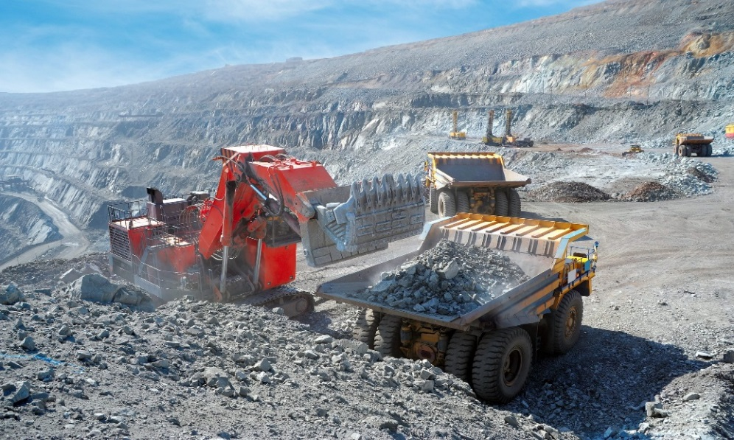

**Task:**

1. Explain the benefits of mining to the development of east Africa
2. What are the problems facing mining in East Africa.

3.Uganda is embraced with a variety of tourist attractions of which have attracted tourists from various parts of the world both within east Africa and out side east Africa.

**Task**

1. Discuss the factors that have favored the development of tourism industry in east Africa
2. Explain the benefits of tourism to the development of east Africa.
3. There are various climatic zones in the world covering various continents of the world.

**Tasks**

1. Identify any five climatic zones of the world
2. Describe characteristics of each climatic zone mentioned in (a) above.

***“There is nothing that succeeds like success***.”

**STANDARD HIGH SCHOOL KAPEEKA**

**P250/3**

**GEOGRAPHY**

**PAPER 3**

**TIME 3HRS**

**Instructions to candidates**

* Attempt any four questions
* Section A is compulsory
* Answer one question from section A and three questions from section B
* Credit will be given to the diagrams, relevant sketch maps and relevant example studied from the field.

**SECTION A (FIELD WORK)**

1.For anyone field work carried out on a landing site.;

(a)(i) State the topic of the study (2mks)

(ii)State the objectives of the study.(3mks)

(b).Describe hoe any three of the following methods were used during the study;

(i) Observation

(ii) Recording

(iii) Interviewing

(iv) Measurement

(c) What challenges did you face using each of the methods chosen in 1 (b)

(d) Assess the impact of a landing site on the environment in the area studied.

2. For any one field work study conducted either as an individual or group; state the;

(i) Topic of the study

(ii) Objectives of the study

(b)Draw a fully annotated sketch map of the area studied

(c)Explain the relationship between the physical environment and human activities in the area studied.

(d)Outline the problems faced during the field work study.

**SECTION B**

3. Examine the influence of faulting on land form development in Uganda(25mks)

4. Examine the factor which have influenced population distribution in Uganda.(25mks)

5. Asses the role of plantation agriculture ton the development of Uganda

6. Examine the factors which have influenced the development of mining sector in Uganda.(25 mks)

7. (a) Asses the role of tourism sector to the development of Uganda(15mks)

(b) What are the problems facing mining sector of Uganda.(10mks)

8. Study the table below showing the trend of fish catch (‘000 tones) in major lakes in Uganda from 2014 -2016 and answer questions that follow.

|  |  |  |  |
| --- | --- | --- | --- |
| **Lake** | **2014** | **2015** | **2016** |
| **Lake victoria** | **245,000** | **250,000** | **260,000** |
| **Lake Albert** | **152,000** | **149,000** | **149,000** |
| **Lake kyoga** | **38,000** | **50,000** | **50,000** |

(a) Draw a comparative bar graph to portray the information in the table.

(b)Describe the trend in the fish caught on lakes shown in the table above

(c) Asses the role of fishing to the development of Uganda.

**“There is nothing that succeeds like success”**

**STANDARD HIGH SCHOOL KAPEEKA**

**P250/2**

**GEOGRAPHY**

**PAPER 3**

**TIME 3HRS**

**Instructions to candidates**

* Attempt any four questions
* Section A is compulsory
* Answer one question from section A and three questions from section B
* Credit will be given to the diagrams, relevant sketch maps and relevant example studied from the field.

**SECTION A**

Study the table below showing imports and exports of sugar in ‘000 tones in selected European countries in 2011 and answer the questions that follow .

|  |  |  |
| --- | --- | --- |
| **country** | **Import (‘000 tones)** | **Export (‘000 tones)** |
| **Germany** | **245,000** | **260,000** |
| **Switzerland** | **152,000** | **50,000** |
| **Netherlands** | **250,000** | **39,000** |
| **Belgium** | **149,000** | **38,000** |
| **Luxembourg**    **Total** | **260,000** | **40,000** |

(a)Use proportional divided semi-circles method to represent the information given in the table above.

(b) Outline the ;

(i) Merits

(ii) Demerits of using the statistical methods in 1(a)

(c) Explain the factors favouring plantation farming in south Africa .

**SECTION B**

2. Account for the development of large scale irrigation farming in either Sudan or California

3. Explain the factors that have led to the development of a strong forestry economy in either Canada or Gabon

4. (a)Describe any two methods used in catching fish in either Peru or Norway

(b) Explain the factors favoring the development of the fishing industry in the country chosen in 4. (a)

5. Explain the factors that have favored the development of inland water transport in either the Rhineland’s of Western Europe or the Great lakes region of North America

6. Explain the challenges facing mining industry in either Zambia or republic of South Africa

7. (a)Account for the occurrence of pollution in either the republic of south Africa or Japan

(b) Asses the effects of pollution on the environment in the country chosen in 8.

8. Examine the conditions influencing the location of rural settlements in either developed or developing countries.

**“There is nothing that succeeds like success”**

**STANDARD HIGH SCHOOL KAPEEKA**

**GEOGRAPHY 273/1**

**TIME: 2 HOURS**

**Instructions:**

Attempt any three items

1.According to the 2021 Uganda Population Survey, the country’s population was estimated to be 42 million, and growing at a rate of 3 % per year.

At this rate, the country’s population is expected to reach 72.4 million people by 2040; representing an annual increase of 1.6 million people per year.

Members of your community have different views about this rate of population growth. Some see it as a benefit, while others think it is a danger to the country

**Support material**

The table showing total population of Uganda between 1980 and 2010

|  |  |
| --- | --- |
| Year | Total population in 000000s |
| 1980 | 126 |
| 1985 | 162 |
| 1990 | 242 |
| 1995 | 346 |
| 2000 | 486 |
| 2005 | 540 |
| 2010 | 600 |

**Tasks**

(a) Draw a suitable graph to show the information in the table.

(b) Using the information provided in the text and table, write an article of between **250 – 300** to be published in one of the local newspapers that will help you deal with the concerns of the members of your community

2. The government has discovered minerals in your area and it wants to start the extraction and establish a processing industry. However, the people who have lived in the area are against the government project because their land is a source of their livelihood in terms of agriculture, hunting and food gathering, wood products, settlement and fishing. The members of the community are mobilizing themselves to fail government efforts in all ways. The government officials have been asked to meet with the members of the community to find a way of how to sensitize them about the government project.

**Support:**



**Task:**

1. With the help of a diagram, describe the method that is used in mining the mineral as shown above in the table.
2. Write a detailed information convincing the community about the goodness of the project such that they can support the government to continue with the project from the above scenario.
3. One of your family members is migrating from villages and he is planning to move out of the country and settle in one of the major cities in Africa. Some the major cities of Africa include Lagos of Nigeria and Johannesburg of south Africa. This is because he has realized the major functions of urban centers.

**Tasks**

1. Write a detailed information as to why Sarah should go and settle in either Lagos or Johannesburg
2. According to you what are some of the dangers that Sarah is likely to be facing while staying in either Lagos or Johannesburg.
3. Forestry is one of the major activities taking place in the tropical country Gabon. Gabon is found in Africa with a variety of tropical rain forests. It is one of the major activities in Gabon. Some people look at the sector as a danger and others look at it as a blessing to the country.

**Support material**

The table showing different tree species in Gabon.

|  |  |
| --- | --- |
| Tree species | Percentage of trees (%) |
| Ebony | 30 |
| Mahogany | 20 |
| Red heart | 15 |
| Mvule | 10 |
| Green heart | 13 |
| Rose wood | 12 |

**Tasks**

1. Draw a pie chart to showing various tree species in Gabon.
2. Write a detailed information showing how the sector is a blessing to the country or a danger.

***“There is nothing that succeeds like success”***